|  | Value | | | | | |
| --- | --- | --- | --- | --- | --- | --- |
|  | Osama | Andrej | Codin | Osman | Yee Yin | Khiem |
| Sex | Female | Male | Female | Male | Female | Male |
| Vision (Out of 20) | 20/70 | 20/40 | 20/20 | 20/25 | 20 | 20/40 |
| Height (cm) | 165 | 170 | 163 | 188 | 150 | 155 |
| Strength (1-10) | 5 | 2 | 3 | 4 | 4 | 3 |
| Weight (kg) | 85 | 50 | 64 | 60 | 46 | 58 |
| Age (Years) | 35 | 84 | 68 | 42 | 30 | 45 |

NEED POOR PERSON, NEED YOUNGER PERSON, NEED MORE BROAD SUC MANY COVER URBAN

| **Vision Ratings** | | |
| --- | --- | --- |
| **Vision Rating** | **Description** | **Vision Quality** |
| 20/20 | Normal visual acuity at 20 feet; you see what an average person sees at 20 feet. | Perfect vision without correction |
| 20/10 | Better than normal vision; you see from 20 feet what a typical person would need to be at 10 feet to see. | Excellent, very sharp distance vision. |
| 20/15 | Better than average; you see from 20 feet what a typical person sees from 15 feet. | Very good; often a goal for corrective surgeries or prescriptions. |
| 20/25 | Slightly worse than average; you need to be 20 feet away to see what most people see from 25 feet. | Minor blurriness at distance, usually correctable with glasses or contacts if needed. |
| 20/30 | You need to be 20 feet away to see what a person with average vision can see at 30 feet. | Mildly blurry at distance, glasses may help with clarity. |
| 20/40 | You see at 20 feet what a person with average vision can see at 40 feet. | Minimum vision requirement for driving without corrective lenses in most regions. |
| 20/50 | You need to be 20 feet away to see what a person with 20/20 vision can see at 50 feet. | Moderate distance blurriness; glasses or contacts recommended. |
| 20/70 | You need to be at 20 feet to see what someone with normal vision sees at 70 feet. | Low vision; often qualifies as "legally low vision." |
| 20/100 | You need to be at 20 feet to see what a typical person sees at 100 feet. | Severe vision impairment; essential corrective lenses or low-vision aids are recommended. |
| 20/200 | You need to be at 20 feet to see what a typical person can see at 200 feet. | Legally blind in the United States; requires strong corrective lenses or specialized assistance. |
| 20/400 | You need to be 20 feet away to see what a person with normal vision can see at 400 feet. | Profound visual impairment; functional blindness. |

**Andrej**

Jameson is a 84 year old man who retired from his assembly line job 5 years ago. Since he now stays at home, he cares for his 2 year old grandson George from time to time. Due to his long and tough career, he has developed many chronic physical pain conditions in his back and knees, making leaning over and pushing heavy objects difficult and painful. As well, he is experiencing muscle degradation due to his age, sapping him of strength. Along with his strength, his eyesight is slowly failing. However Jameson is a stubborn man, so he refuses to wear glasses. When taking Goerge outside, he cannot carry him around, instead needing a stroller to move him. Not only does it need to be light for Jameson to safely operate it, but it must have very large and easy to use functions. As well, Jameson is very suspicious of new technology, so it must be very simple to understand.

| **SUC 1** | **Jameson** |
| --- | --- |
| **Owner:** | Andrej |
|  | 84-year old Jameson takes his grandson George on a quick grocery trip around the block. SInce he cannot legally drive, he needs to get there and back with both Geroge and the groceries in tow. Due to his lack of strength and vision, the lightweight stroller with easy to read instructions is a lifesaver. As well, when he gets to his rather small bungalow, the simple folding mechanism lets him understand the instructions and save space.  **Relevance:** This scenario shows many important factors that need to be considered when designing the intervention. FIrstly, it must be very light and maneuverable in order for people with low or degrading strength to use it/keep using it. Instructions need to be high contrast and large for people with vision disabilities. Large amounts of storage space is a huge bonus for Jameson, who needs it for groceries and other errands. A simple and effective folding mechanism is also necessary for small living areas like Jameson’s home. |

**Yee Yin**

Caitlynn is a 40 years old stay at home mother who recently had a child. She lives with her spouse however they are not at home often as they work long hours. Due to a severe car accident in her 30’s she is missing her right leg and has phantom pain and is physically weak. She has some difficulty walking as she biases her remaining leg as it hurts for her to walk on the prosthetic. Despite her disability she prefers to walk and take public transport over driving on her own. She is strong willed and prefers to do things on her own without the help of others, often going to buy groceries on her own despite her spouse's protests.

| SUC | **Caitlynn goes on a errand run on a rainy day** |
| --- | --- |
| Owner | Yee Yin |
|  | On a fall cold afternoon Caitlynn needs to go and run some errands nearby. She can’t leave her child at home so she has to bring them with her. On this day it was raining quite heavily, as a result an umbrella was required. The rainy day also made her leg act up, making it harder for her to walk. Needing to get these supplies before her spouse gets home, she goes to run her errands.  **Relevance:** The scenario shows the importance of a stroller that can assist the user when needed. Having an assistive motorized stroller allows for someone who may have difficulty walking/ pushing the stroller to have an extra push to help them move the stroller. |

**Khiem**

Thanh Nguyen is a 32 years old software developer from Vietnam, who lives in Toronto with his wife and their 9-month-old son, Duy. Since moving to Canada three years ago, he’s been adapting to life in a new city and is still improving his English, which makes reading complicated instructions challenging. Thanh was born without his right forearm, so he got used to using his left hand for nearly everything, but pushing a stroller on Toronto’s busy streets can still be a hassle without that second hand.

Thanh needs a stroller he can handle easily with one hand, whether he’s folding it up or steering. A lightweight build would let him carry it without strain, and brakes that are easy to lock with his foot would be ideal for quick stops. With straightforward, picture-based instructions and a compact, no-fuss design, Thanh could focus on just enjoying his time out with Duy. He values products that make things simple and easy, keeping his day-to-day as smooth as possible.

| **SUC 2** | **Thanh Navigates Busy Toronto Streets with a Stroller on a Rainy Day** |
| --- | --- |
| **Owner** | Khiem |
|  | On a bright Saturday morning, Thanh takes his 9-month-old son, Duy, to a local park. Navigating Toronto’s crowded sidewalks, he steers the stroller with his left hand — his only hand, as he was born without a right forearm. Moving through busy pedestrian areas and crossing streets can be tricky without a second hand to quickly adjust the stroller. When they reach the park, Thanh needs to fold the lightweight stroller with one hand to carry it up a few steps, as there’s no ramp. Clear, picture-based instructions are essential for him to work the stroller’s features smoothly, especially since he’s still getting comfortable with English.  **Relevance**: This scenario shows the importance of a stroller that’s easy to steer with one hand, lightweight for easy carrying, has a one-handed folding option, and comes with foot brakes for quick stops. Visual instructions make it simpler for Thanh to use, offering straightforward guidance that fits his needs. |

**Codin**

Margaret is a 68-year-old woman who lives alone but often cares for her 2-year-old granddaughter, Emily, while her daughter is at work. Margaret was diagnosed with early-stage dementia two years ago, which occasionally affects her short-term memory and makes complex tasks a little confusing. Despite this, she is strong and active, walking daily and enjoying gardening to stay physically fit and mentally engaged. She values her independence and is determined to keep doing things on her own as much as possible. Margaret prefers walking to driving, finding it simpler and safer. She often takes Emily to the park. Margaret is deeply caring and patient, and time spent with Emily is something she treasures. It’s a reminder of all the meaningful connections in her life, and she feels grounded and purposeful caring for her granddaughter. As her condition progresses, Margaret looks for tools and products that allow her to remain involved with her family safely and independently, finding joy in the little moments with Emily.

| **SUC 3** | **Margaret takes Emily to the park in the afternoon** |
| --- | --- |
| **Owner:** | Codin |
|  | Margaret, a 68-year-old woman with early-stage dementia, takes her 2-year-old granddaughter Emily to the park at 3:00 p.m. on a sunny day. Margaret values her independence and finds walking simpler and safer than driving, especially with Emily in tow. She brings along a stroller and a small backpack with essentials for their trip.  **Relevance:** This scenario highlights the need for a human-powered vehicle designed for infants and toddlers that enhances Margaret's independence while ensuring Emily's safety. Considering Margaret’s occasional memory lapses, the design should prioritize an intuitive design with simple visual instructions for folding and securing Emily. The design should include automatic safety locks to prevent unintentional folding or rolling. Incorporating a storage compartment or organizer on the stroller would enable Margaret to keep essentials like water and snacks within arm's reach, reducing stress and enhancing their overall park experience. |

**Osman**

John is a 42-year-old male living with his 2-year-old toddler in a compact apartment complex with minimal storage. John is a single father who works from home and manages both his graphic designing job and the caretaking of his toddler. John is quite busy with his job, he works extra hours in order to provide for his toddler, and his financial situation forces John to budget appropriately and spend responsibly. Despite that John makes as much time as he can to take his toddler for walks. John has a significant and frequent need for long walking commutes in order to reach places such as grocery stores, John also takes his toddler with him on these commutes. Due to John's recent back surgery, it prohibits him from lifting heavy objects and limits movement to prevent any pain from occurring. Furthermore, John is a tall individual, at 188 cm needing a design that accommodates above average heights in order to comfortably maneuver with the stroller. John faces the challenge of maneuvering through the busy and uneven terrain of the city and due to his lack of strength, John stresses the need for high-stability in order to prevent tipping or uncomfort for his toddler. Moreover, Johns stresses the need for his toddler to develop good posture habits from a young age to not end up with any future back issues like himself.

| **SUC 4** | **John takes his toddler with him to the grocery store** |
| --- | --- |
| **Owner** | Osman |
|  | On a typical afternoon John needs to go grocery shopping, taking his toddler along with him. Traversing the busy streets of the city he walks through the rough and uneven terrain. John walks through several blocks, ensuring his toddler is comfortable and shaded well from the blazing sun using an umbrella. Due to his back injury, John struggles with pushing the stroller with the necessary force consistently, which creates a more difficult ride for him and his toddler. Furthermore, due to his staggering height, the handlebars are positioned quite low for him, creating an unnatural wrist position and putting extra strain on his back and shoulders. After arriving at the grocery store, John carries his groceries in the bags given which add onto the weight and strain on John. After arriving home, John struggles in accommodating a compact area for the design, resulting in a larger space being occupied then intended.  **Relevance:** This Scenario highlights the importance of an intervention that incorporates many aspects that allow for an easy, safe and comfortable experience for John and his toddler. As John goes on his grocery trip, an intervention that is capable of long rides without fail, for long-term use without major wear and tear is necessary for John. Furthermore, an intervention that has high stability through a variety of terrains allows for easy maneuverability through the busy and unpredictable city streets. Additionally, a means to add in creating less force required to push the assistive transport aids John to not be prone to injury and allow for a more safe ride. Adjustable handlebars are also essential for John’s height allowing for neutral wrist position and less strain on his back. Lastly, a means of storage is essential for the intervention, allowing for means to store the grocery without having to carry it while maneuvering the design. |

**Osama**

Rachel is a 35 year old female who regularly takes care of her 3-year old niece. She recently quit her full time job at Tim Horton’s due to worsening multiple sclerosis which causes her to lose balance after standing on her feet for an extended period of time. She hopes to find a new job, but in the meantime she spends her time playing dungeons and dragons in her best friend's basement. After the birth of her sister’s son, going on walks in the park with her niece has been almost the only time that she spends time outdoors. She especially struggles to leave the house during the rain, as her thick prescription glasses are impossible to see through when wet, and she is unable to wear contacts due to the dexterity required to put them on.

| SUC 1 | Rachel taking an up-hill route while on a walk with her niece |
| --- | --- |
| Owner | Osama |
|  | Rachel’s niece decides she wants to take a new route on their weekly walk, and this new route involves an uphill portion. Relevance: Rachel will have to use extra force to push the intervention and must stabilize it from falling for an extended period of time. |

| **HF DEMAND** | **US STEP WITH HIGHEST DEMAND (#, description** | **% Excluded** | **Comment** |
| --- | --- | --- | --- |
| Vision | 2C: Pushing the intervention, looking at surroundings | 0.9 | Ensures the user can see potential obstacles, pedestrians, or changes in terrain while pushing the stroller, allowing for safe navigation and quick responses to hazards |
| Hearing | 2C: Pushing the intervention, hearing surrounding noises and child | 1.4 | Ensures the user is aware of their surroundings and the wellbeing of the child, as the child is out of sight from the user when in use. |
| Concentration memory | 3: Folding and storing stroller | 3.4 | The user must identify that child is safely out of intervention before folding, and be able to concentrate on task of folding while being able to read and comprehend the folding instructions as given in the manual |
| Strength & dexterity (dominant) | 3: Folding and storing intervention | 7.8 | There is demand on the user to be able to lift and control the intervention |
| Strength & dexterity (non-dominant) | 3: Folding and storing intervention | 7.4 | There is demand on the non dominant hand to support the rest of the intervention while folding and storing is taking place |
| Walking and Mobility | 3: Folding and storing intervention | 6.1 | There is demand on the user to stand without holding onto any support while folding the intervention, as well as walking short distances around the intervention |

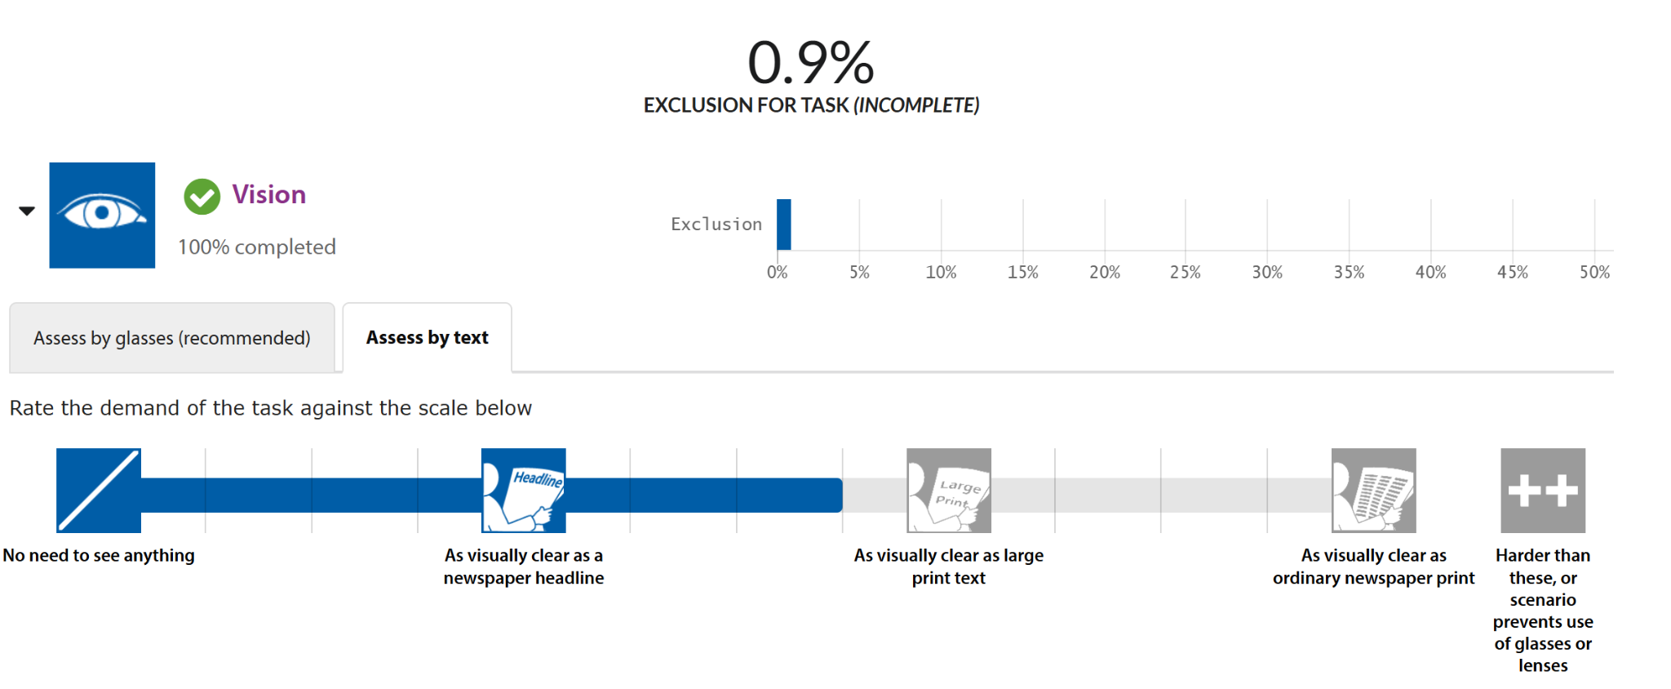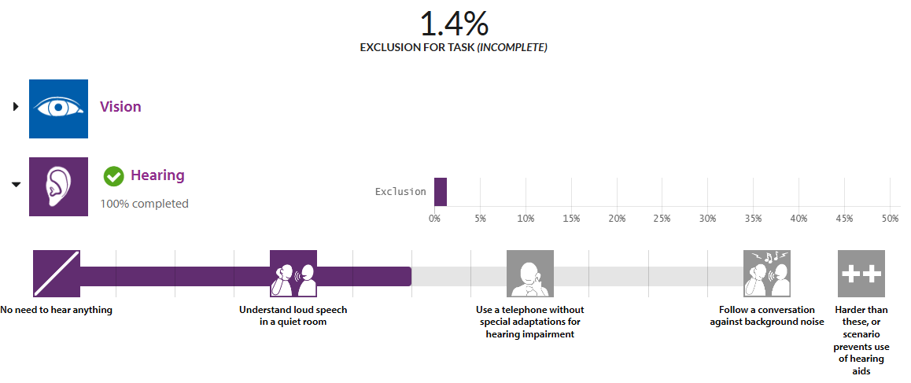

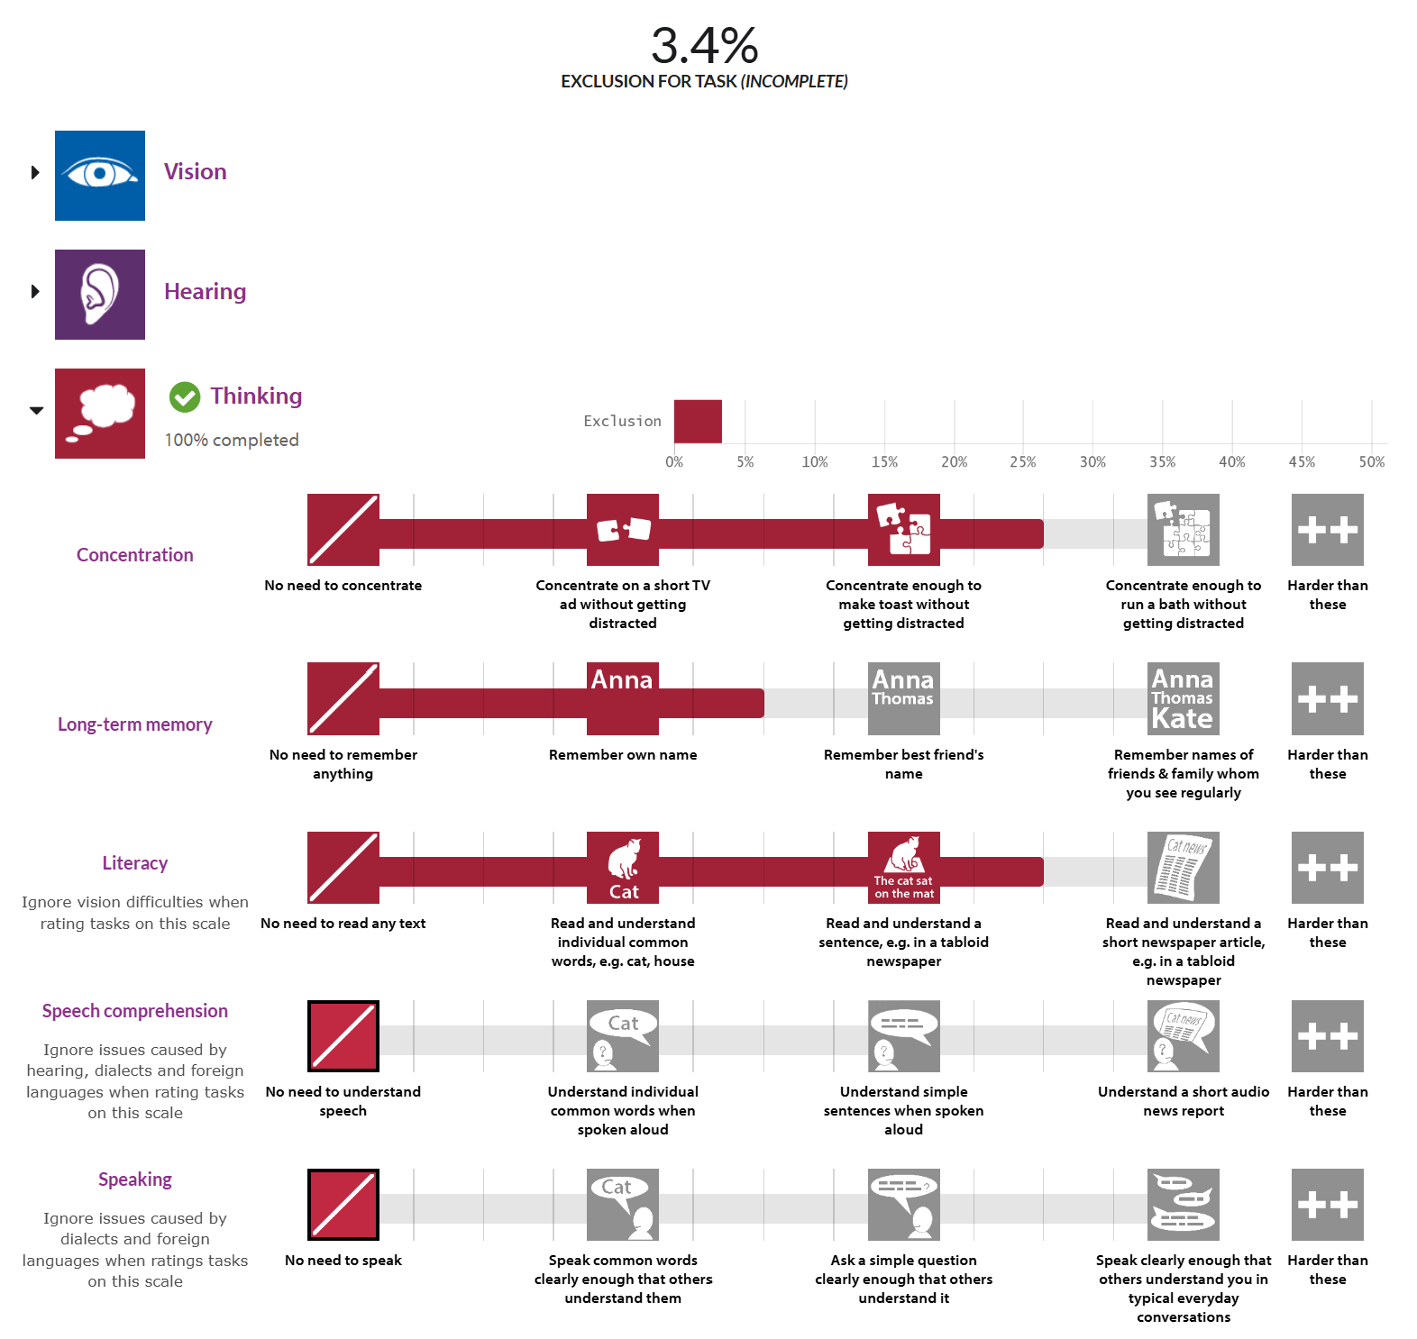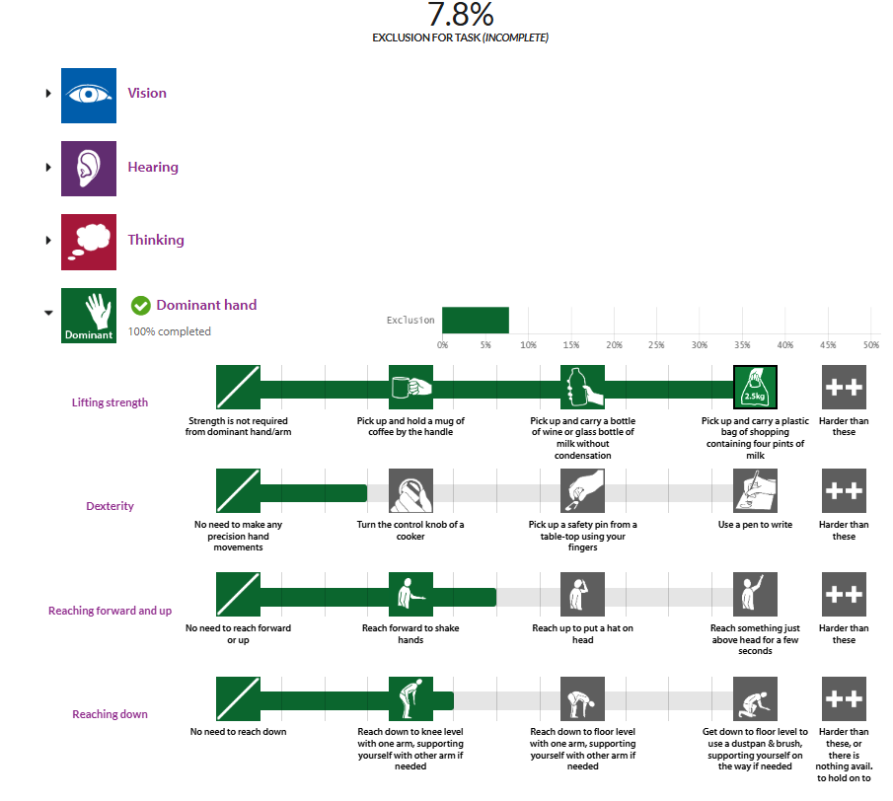

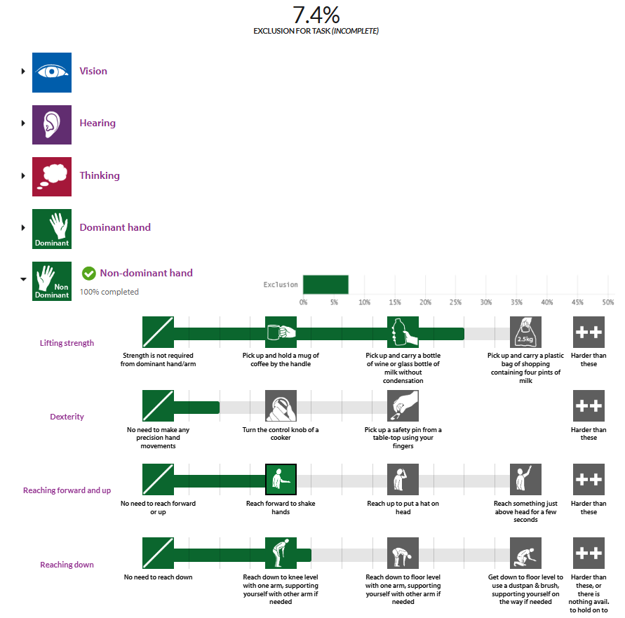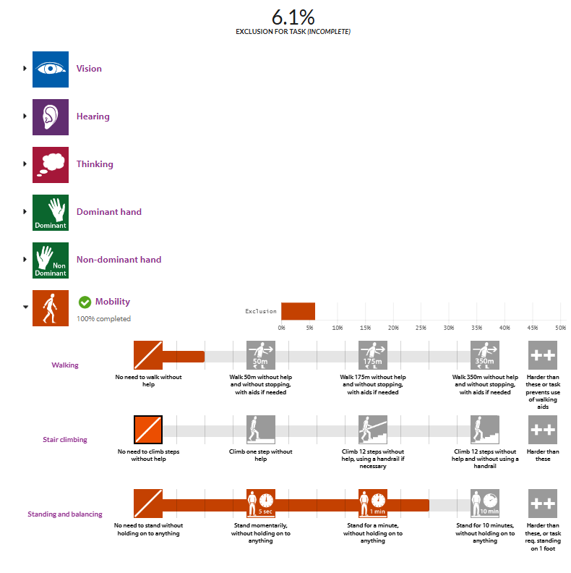

* Design issues:
  + 2C: The intervention demands the use of hearing audio cues to check on the wellbeing of the child due to the fact that the child is out of sight from the user
  + The intervention demands the lifting of the device in both setup and put-away